English I, Notemaking, page 3
- Use _MID-SECTION_ for notes.
Get everything that is important and make it yours. If a chart, graph, table, illustration, definition, equation, formula, new term, or any other aid to learning is presented, then GET IT! And, record it in the middle section of your notes.

III. HELPFUL SUGGESTIONS FOR MAKING NOTES

- Notes need not be grammatically full _SENTENCES_, but must be enough to help you recall class discussion when studying. Acquire the habit of omitting a and an except when necessary. Use numerals instead of writing out numbers.

- _CONCENTRATE_ and acquire the real meat of the lesson, recording only essentials and opening your mind to meaning.
Just what should you hope to gain from a lecture?
- Make note of _HEADINGS_. One can readily detect major headings and sub-headings in any competent lecture.
If the lecture is not competent masses of notes will not help anyway.

- Any points that seem to be new, original, or have special _SIGNIFICANCE_ make note of them.
? How does one recognize new, and original ideas?
By PRE-READING!!!

- _QUESTIONS_ that are asked; especially those that remain unanswered.
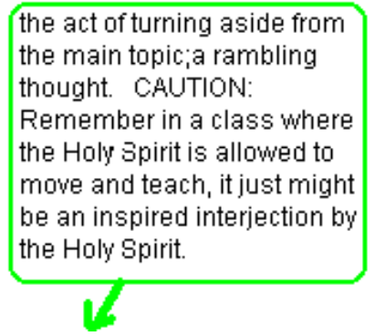

- _COMMENTS_ pointing to possible exam questions.

- Challenge the lecture:
 What does he mean by that?
 Where does that fit in?
 Is that comment essential; or, is it a digression?
 He said, “…four points;” he only made three; or, was such and such intended to be #4?
 That’s not what the book said; or,…what I heard;
or, am I
 Isn’t he going to discuss…?

English I, Notemaking, page 4
- Consider _TIME SPENT_ on a particular point.
More important = More attention
- Consider _REPITITION_ of a particular point/ the # of times the same point is made.
A good indicator of importance = repitition.
- Consider the _GESTURES_ and _TONE _ used to make a particular point.

- WHEN YOU ARE FINISHED MAKING NOTES, YOU SHOULD:

- _REVIEW _ your notes!
- _ORGANIZE _ your notes, the same day, by all means!

- If notes are from a lecture; then, Make a summary or skeleton _OUTLINE _.
- Draw lines, balloons, brackets, braces, numbers, underline, etc.
- Note all significant _POINTS _ not included in text.
- Draw a light _SLOPING LINE _ through omitted or slightly dismissed material.

CONCLUSION: If these suggestions cannot, or do not, help; then, remember, often a teacher likes to leave pulling material together until the end of the class. When suddenly all has a new and important meaning. The best way to make notes in such a class is to sit still for a few minutes and in 3 or 4 sentences putting down the principle idea(s) of the lecture. This requires a little discipline but it is worth it and it is less frustrating.

SUMMARY: In summary – 4 Things to Remember –
- Prepare yourself to listen.
- Listen and think before you write.
- Make notes easy to understand.
- Thimk ahead to examination time.

NOTE IN CLOSING: The worst technique in taking notes (aside from inattention, fatigue, inadequate preparation, etc.) can be summed up in one word –
Scribblemania.
It consists of sitting in class with no apparent object in mind, but to write as much as possible. PLEASE, come to class prepared to receive something substantial.

